

Share
highs and lows


Read
a Bible verse
or story


Talk
about how the
Bible reading
might relate to
your highs
and lows


Pray
for one another’s
highs and lows


Bless
one another

PENTECOST SEASON 2016 (June 5-July 23) 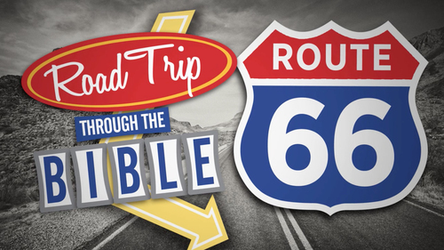

“Road Trip through the BIBLE”
Dear Brothers and Sisters in Christ,
The long season of Pentecost is upon us, as is summer!
So, let’s do something a little different and fun for the summer.
Let’s take a road trip together through the 66 books of the Bible!
What will that look like??
Over the 14 weeks from June 5 through the week of Labor Day we’ll read a verse or short passage (a couple of times several) from each book of the Bible starting with Genesis! The devos will still include Sunday gospel readings on Saturdays. We’ll distribute these Devotions in two sets – 7 weeks of passages each time – on June 5 and July 24. They will also be available on the website.

For your DEVOTIONS:
On the back are Bible passages and stories for little ones for use in your personal or family devotions June 5 through July 23 of the Pentecost season. We invite you to use them in the context of the Faith 5, but however you use them, we hope they enrich your days! The next set will be distributed on July 24th.

Now a word about the calendar of readings:
The line marked simply “BIBLE” is for all adults and families with school age children and youth. The verses come from all the books of the Bible – starting with Genesis and goin’ straight through! Each Saturday we’ll pause to read Sunday worship’s Gospel lesson.

The line marked “READ with ME BIBLE” is for families with children who are very young. You’ll read stories from throughout the Bible that help little ones understand God’s whole story. If you don’t have a “Read with Me Bible” and want one – just let me know! I included three stories a week so you can read each a couple of times.

I will continue to post daily verses and a short comment about each on the Christ Lutheran Church Facebook page (facebook.com/christlutheranchurchdubois).

May your devotions be fruitful and your days blessed. Peace+, Pastor Amy

