COMING THIS SUMMER TO CHRIST CHURCH!!
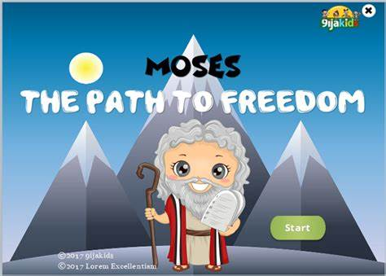
SUMMER CAMP
MOSES: The Path to FREEDOM
for children 3 years old through 5th grade,
with opportunities to help lead for teenagers and adults

Monday-Thursday, July 25 – 28, 2022
Monday-Thursday: 5:30 sharp dinner; 5:50-7:40 the program
Thursday: 7:00 performance followed by dessert in the pavilion

During this weeklong camp, there will be something for everybody – story, recreation, hands on activities, crafts, music and snack time! We need many volunteers to help with the effort. We need folks for the kitchen, to lead games, to prepare the activities and more! Let us know if you can help. We also encourage youth to sign up to help!

USE THE FORM BELOW TO REGISTER!!
Let’s put together and enjoy together another wonderful summer camp!!
Call Nikki Dombroski or Pastor Amy at the church 814-371-2470 or email at: dombroski43@verizon.net or pastorsmiller12@gmail.com with any questions!

**********************************************************
SUMMER CAMP – REGISTRATION FORM
MOSES: The Path to FREEDOM
Monday, July 25 – Thursday, July 28, 2022

Family Name _________________ Address: ________________________________

Home Phone________________ Cell Phone(s) ________________________________
Email address __________________________Home Church _____________________

Participants: Names & grades just completed: ____________________________________

Volunteers:
Youth (entering 6th grade & older): _______________ Adult:_____________________

Known allergies or other medical conditions of which we should be aware ___________
____________________________________________________________________
We plan to come for dinner at 5:30 - _____ adults/youth _____ children

