



**Share**

highs and lows



**Read**

a Bible verse

or story



**Talk**

about how the

Bible reading

might relate to

your highs

and lows

-

**Pray**

for one another’s

highs and lows



**Bless**

one another

**PENTECOST SEASON 2023 (Part One: September 10-October 14)**

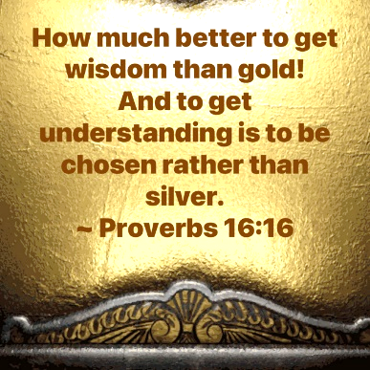

“Get Wisdom!”

Dear Brothers and Sisters in Christ,

The long season of Pentecost continues, and it is time for a new congregational devotion, one which will take us right up to the Advent season.

Professor Daniel J. Ebert IV gets us started with a good definition: “Biblical wisdom **invites people to a way of life that is in harmony with both the created order and God's redemptive work**. In the Old Testament wisdom is oriented around the fear of the Lord; in the New Testament wisdom is amplified and reoriented around Christ.”

**Wisdom, in other words, is understanding and living life from God’s perspective.** Throughout the book of Proverbs, Solomon encourages us to “get wisdom.” In fact, he declares: “How much better to get wisdom than gold!” (Proverbs 16:16a)

**But how do we do so? What does the Bible say about wisdom? Is a lack of wisdom part of the problem today, as it has been through many ages before our own? What wisdom does Jesus share? How is Jesus Himself wisdom?**

These are some of the questions I hope we can answer together as we “Get Wisdom” from the Bible in our new devo which begins on September 10. In the first five weeks, on this our first calendar, we will concentrate on Old Testament wisdom centered around King Solomon, his Proverbs, and some wisdom Psalms.

I will continue to post daily verses & a short comment about each on **the Christ Lutheran Church Facebook page** *(**facebook.com/christlutheranchurchdubois**).* Or you can **join our e-mail group** and receive the same daily verses and short comment. Simply send a request message to pastorsmiller12@gmail.com.

*Blessings on your devotions, Pastor Amy*