Dear Brothers and Sisters in Christ,
Easter is our season to celebrate Jesus’ victory over sin and death; a victory which we all share
– new life now and life eternal with our Risen Savior. In John 11, not long before Jesus’ final
days, He and His disciples arrived in Bethany after their friend Lazarus had died and was buried. Lazarus’ sister Martha came out to meet Jesus. He said to her: “I am the resurrection and the life. Those who believe in me, even though they die, will live.” Then Jesus asked Martha a question, a crucial question: “Do you believe this?” Her reply was clear, decisive and full of faith: “Yes Lord, I believe that you are the Messiah, the Son of God, the One coming into the world.” During the Easter season we celebrate Jesus and answer the call to faith in Him - the resurrection and life!
This season let’s explore what the Bible says about Jesus, the resurrection and the life and discover anew and again what it means for us! As we do, may we all grow in faithfulness and in our commitment to live the Easter life. May we with Martha say: “Yes Lord, I believe!”
These devos take us through the 7 weeks of the Easter Season – March 31 through May 18. Below are two Easter hymns upon which we will also reflect as noted on the devo calendar (on the back). This is a repeat devotion from Easter 2020; a study which was well received and therefore worth repeating. We have still included Sunday gospel readings on Saturdays. We invite you to use these devos in the context of the Faith 5, but however you use them, we hope they enrich your days!
^{EASTER SEASON, 2024}
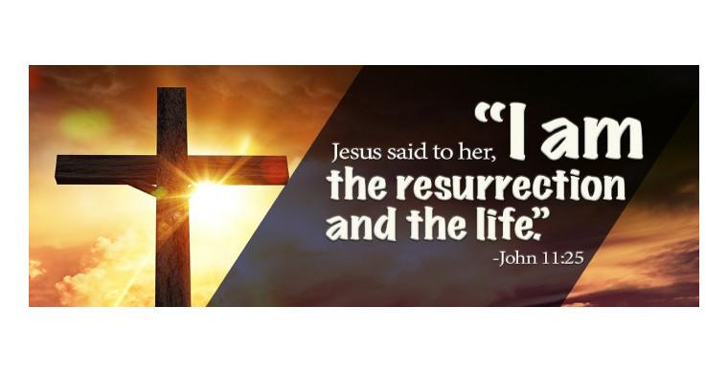
Share
highs and lows

Read
a Bible verse
or story

Talk
about how the
I will continue to post the daily passages and a short comment on the Christ Lutheran Church Facebook page (facebook.com/christlutheranchurchdubois). This is also available in a daily e-mail. To join this group simply email me and ask – pastorsmiller12@gmail.com.

May this study of Jesus’ triumph o’er the grave bring us joy! Peace+, Pastor Amy
Bible reading
might relate to
your highs
and lows

THINE IS THE GLORY
by Edmond Budry (1854-1932)
1. Thine is the glory, risen, conqu'ring Son:
endless is the vict'ry thou o’er death hast won!
Angels in bright raiment rolled the stone away,
kept the folded grave-clothes where thy body lay.
Refrain:
Thine is the glory, risen, conqu'ring Son;
endless is the vict'ry thou o’er death hast won!

2. Lo, Jesus meets thee, risen from the tomb!
Lovingly he greets thee, scatters fear and gloom;
let his church with gladness, hymns of triumph sing,
for the Lord now liveth; death hath lost its sting! [Refrain]

3. No more we doubt thee, glorious Prince of life;
life is naught without thee: aid us in our strife;
make us more than conqu'rors, through thy deathless love:
bring us safe through Jordan to thy home above. [Refrain]

5. He lives to bless me with his love.
He lives to plead for me above.
He lives my hungry soul to feed.
He lives to bless in time of need.

6. He lives, my kind, wise heav’nly Friend.
He lives and loves me to the end.
He lives, and while he lives, I’ll sing.
He lives, my Prophet, Priest, and King.

7. He lives and grants me daily breath.
He lives, and I shall conquer death.
He lives my mansion to prepare.
He lives to bring me safely there.

8. He lives! All glory to his name!
He lives, my Savior, still the same.
What joy this blessed assurance gives:
I know that my Redeemer lives!

I KNOW THAT MY REDEEMER LIVES
by Samuel Medley (1738-1799)
1. I know that my Redeemer lives.
What comfort this sweet sentence gives!
He lives, he lives, who once was dead.
He lives, my ever-living Head.

2. He lives triumphant from the grave;
He lives eternally to save;
He lives exalted, throned above;
He lives to rule his church in love.

3. He lives to grant me rich supply.
He lives to guide me with his eye.
He lives to comfort me when faint.
He lives to hear my soul’s complaint.

4. He lives to silence all my fears.
He lives to wipe away my tears.
He lives to calm my troubled heart.
He lives all blessings to impart.

Pray
for one another’s
highs and lows

Bless
one another

