



**Share**

highs and lows



**Read**

a Bible verse

or story



**Talk**

about how the

Bible reading

might relate to

your highs

and lows



**Pray**

for one another’s

highs and lows



**Bless**

one another

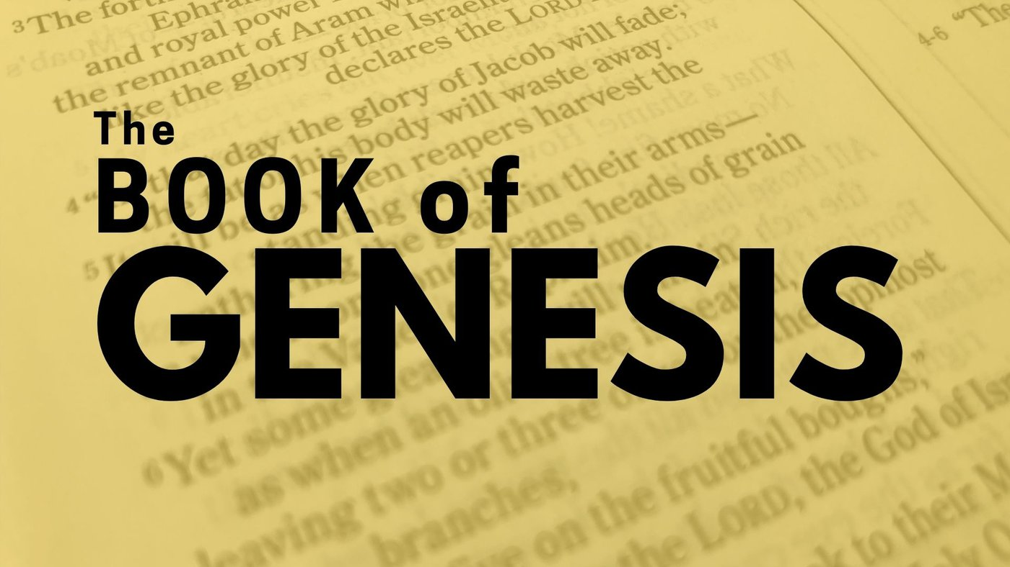

**MID-PENTECOST SEASON DEVOS**

**Part One**

**July 13 - August 17, 2025**

“Reading through Genesis,

Part One: Genesis 1-11,

God and the Whole World!”

Dear Brothers and Sisters in Christ,

As the Pentecost season continues, I invite you to read together the Book of Genesis. This book of beginnings is crucial because

it lays the foundation for understanding the Bible and the Judeo-Christian worldview. It tells the story of creation, the fall of humanity, and the beginnings of God's chosen people, forming the basis for understanding humanity's relationship with God,

the nature of sin and salvation, and the purpose of life.

The book of Genesis is the first book of the Bible. It is divided into two main parts, with chapters 1-11 telling the story of God

and the whole world, and chapters 12-50 focusing in on the story of God, Abraham and his family. A sort of "hinge" story at

the beginning of chapter 12 connects these two parts.

The Big Idea in Genesis is out of disorder and darkness, God creates order, beauty, and goodness; from Genesis 3 onward, humans continue acting selfishly and doing evil, but God remains faithful and refuses to abandon them or His world.

In this first part of the series, we will read chapters 1-11 and the hinge story in chapter 12. These chapters include the two creation stories, the story of the fall, Cain and Abel, the flood narrative, the tower of Babel and the beginning, the hinge part,

of Abraham’s story.

The calendar, with an introduction to this study, will be available on our website, in the narthex or from the church office by Sunday, July 13. Part two begins on August 18.

I hope you will join us in re-reading or reading for the first time this very important book of the Bible. I believe you will find it

able to do what Martin Luther promised in his Large Catechism: *“Nothing helps more powerfully against the devil, the world,*

*the flesh, and all evil thoughts than occupying oneself with God’s Word, having conversations about it, and contemplating it.”*

Blessings on your daily devotions, Pastor Amy