



**Share**

highs and lows



**Read**

a Bible verse

or story



**Talk**

about how the

Bible reading

might relate to

your highs

and lows



**Pray**

for one another’s

highs and lows



**Bless**

one another

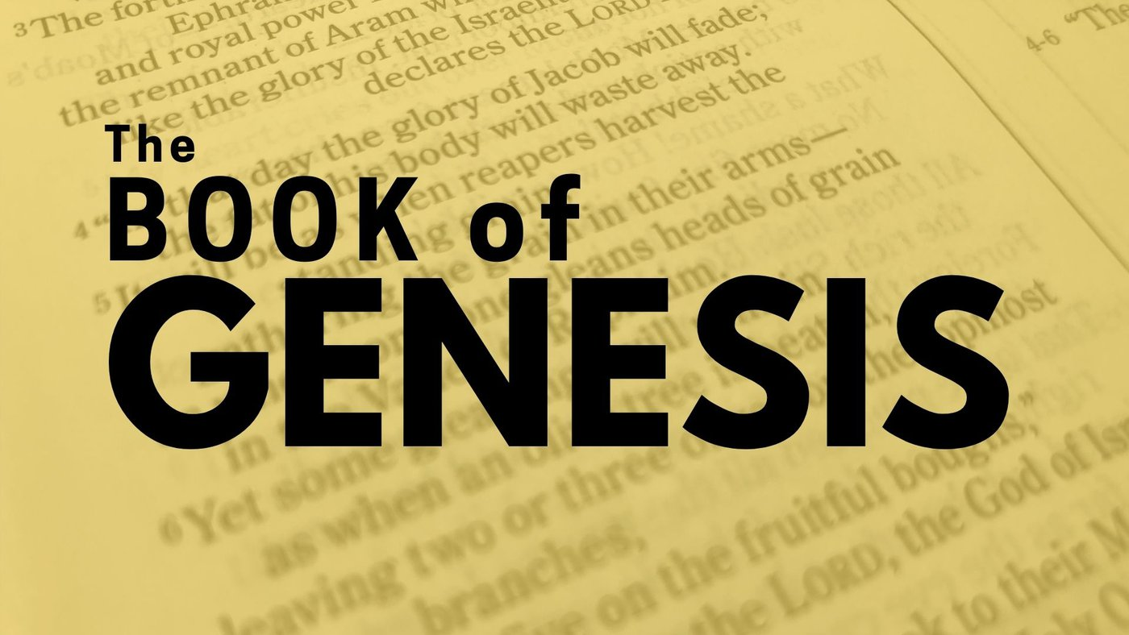

**MID-PENTECOST SEASON DEVOS**

**Part TWO**

**August 18 – September 27, 2025**

“Reading through Genesis,

Part Two: Genesis 12-35,

God, Abraham and his Family: Abraham, Isaac and Jacob”

Dear Brothers and Sisters in Christ,

As the Pentecost season continues, we continue to read through the Book of Genesis together. This book of beginnings is crucial because it lays the foundation for understanding the Bible and the Judeo-Christian worldview.

The book of Genesis is divided into two main parts, with chapters 1-11 telling the story of God and the whole world, and chapters 12-50 focusing in on the story of God, Abraham and his family. With our second calendar we dive into part two with chapters 12-35; Abraham, Isaac and Jacob’s stories. There will be a third calendar for reading the Joseph story, chapters 36-50.

After the debacle at Babylon, we read a hinge story that links the two parts of the book of Genesis together. The author traces the genealogy of one family after the scattering of people from Babylon, and it leads to a man named Abram, later known as Abraham. God’s promise to Abraham at the beginning of chapter 12 opens up a whole new movement in the story - one of promise and blessing. God furthers His hope for humanity by calling one people out of all the earth to be His chosen people.

I hope you will join us in re-reading or reading for the first time this very important book of the Bible. One can easily join in at this point in the story, so please take up your Bible and let’s read the story of Abraham and Sarah’s family together.

The calendar of readings on the reverse side begins on August 17. Our devo still includes Sunday gospel readings on Saturdays. The final and third calendar will come out on Sunday September 28.

These devotions are also available on our website. I will continue to post daily verses and a short comment about each on the Christ Lutheran Church Facebook page (facebook.com/christlutheranchurchdubois). If you would like to receive this daily post via email, please send a request to me at pastorsmiller12@gmail.com.

Blessings on your daily devotions, Pastor Amy