



**Share**

highs and lows



**Read**

a Bible verse

or story



**Talk**

about how the

Bible reading

might relate to

your highs

and lows



**Pray**

for one another’s

highs and lows



**Bless**

one another

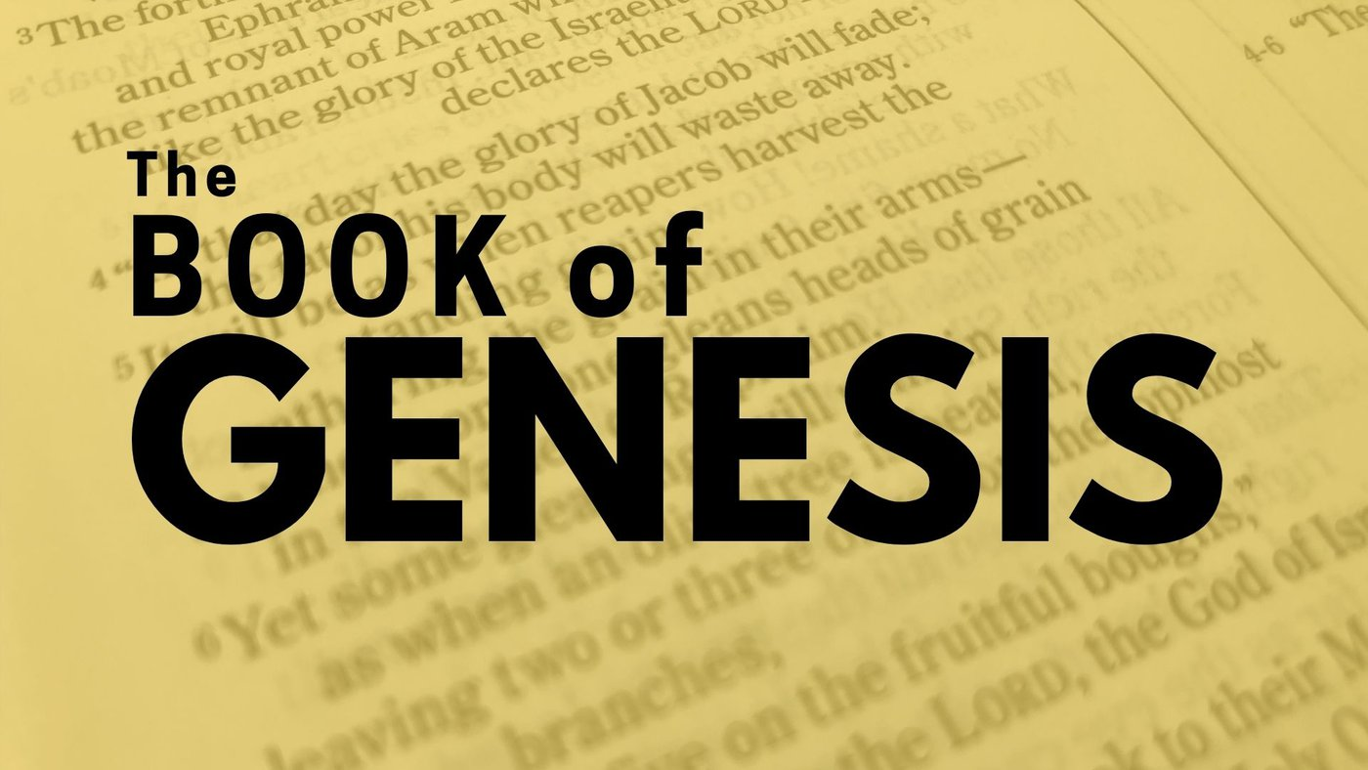

**LATE-PENTECOST SEASON DEVOS**

**Part THREE**

**September 28 - November 1, 2025**

“Reading through Genesis,

Part Three: Genesis 37-50, “Finishing the Story: Joseph”

AND bonus verses which connect this important book to the New Testament!

Dear Brothers and Sisters in Christ,

This month we conclude our reading of Genesis in its entirety. The last thirteen chapters are Joseph’s story. Also, we’ll dive into some passages in the New Testament which rely on Genesis’ themes and stories. I hope this will help us see the strong connection between our roots in these Old Testament stories and our Christian faith.

Just to review: the book of Genesis is divided into two main parts, with chapters 1-11 telling the story of God and the whole world, and chapters 12-50 focusing in on the story of God, Abraham and his family. Remember the big ideas in Genesis are out of disorder and darkness, God creates order, beauty, and goodness; from Genesis 3 onward, humans continue acting selfishly and doing evil, but God remains faithful and refuses to abandon them or His world. The last two weeks of this third part will be verses and passages in the New Testament that make connections to Genesis and these big ideas. These passages show Jesus connection to the story laid out and begun in Genesis.

I hope you have enjoyed re-reading or reading for the first time this very important book of the Bible and that you find the New Testament passages helpful. The calendar of readings on the reverse side begins on September 28. Our devo still includes Sunday gospel readings on Saturdays. The final and third calendar will come to an end on November 1.

These devotions are also available on our website. I will continue to post daily verses and a short comment about each on the Christ Lutheran Church Facebook page (facebook.com/christlutheranchurchdubois). If you would like to receive this daily post via email, please send a request to me at pastorsmiller12@gmail.com.

Blessings on your daily devotions, Pastor Amy