

Share
highs and lows


Read
a Bible verse
or story


Talk
about how the
Bible reading
might relate to
your highs
and lows


Pray
for one another’s
highs and lows


Bless
one another

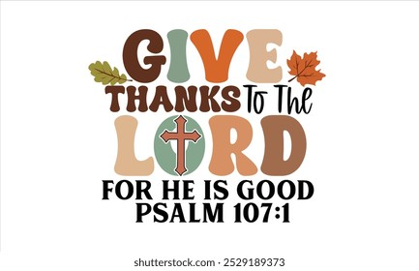
LATE-PENTECOST SEASON DEVOS
November 2-November 29, 2025

“O give thanks to the Lord, for he is good;
for his steadfast love endures forever!” Psalm 107:1

Dear Brothers and Sisters in Christ,

Paul begins his letter to his beloved Philippians with this thanksgiving: “I thank my God every time I remember you, constantly praying with joy in every one of my prayers for all of you, because of your sharing in the gospel from the first day until now. I am confident of this, that the one who began a good work among you will bring it to completion by the day of Jesus Christ.” This is my thanksgiving for all of you my friends and fellow Christians. I wanted to take this month to fill our hearts and devotions with thanksgiving both in preparation for our yearly national holiday and in celebration of our partnership in ministry these past almost 13 years.

The Bible is full of calls to give thanks, to praise, to extol the Lord for all His gifts and benefits. I hope you enjoy reading passages of thanksgiving this month and remember just how important thanksgiving is to your discipleship and in your prayers. The study concludes on November 29, the day before we enter the Advent season.

Advent devotions, which will begin on November 30, will be available at church that day and posted on our website.

I will continue to post daily verses & a short comment about each on the Christ Lutheran Church Facebook page (facebook.com/christlutheranchurchdubois). Or you can join our e-mail group and receive the same daily verses and short comment. Simply send a request message to me at pastorsmiller12@gmail.com.

In Christian love and with gratitude for you, Pastor Amy

